**LAB4;**

**19K-1084**

**BSE-5A**

EXERCISE;

**Q1;**

Socket programming is a way of connecting two nodes on a network to communicate with

each other. One socket(node) listens on a particular port at an IP, while other socket

reaches out to the other to form a connection. Server forms the listener socket while client

reaches out to the server.

**Q2;**

LISTEN[ PARAMETERS]

PARAMERTERS DECIDES HOW MANY CONNECTIONS SHOULD BE MADE.

TO MAKE A LISTEN ONLT CONNECTION ;… LISTEN[1] WILL BE PASSED.

**Q3;**

**TCPSERVER.PY**

from socket import *

serverPort = 12000

serverSocket = socket(AF_INET,SOCK_STREAM)

serverSocket.bind(('',serverPort))

serverSocket.listen(3)

print('The server is ready to receive')

while True:

connectionSocket, addr = serverSocket.accept()

sentence = connectionSocket.recv(1024).decode()

capitalizedSentence = sentence.upper()

connectionSocket.send(capitalizedSentence.encode())

connectionSocket.close()

**TCPCLIENT.py**

from socket import *

serverName = 'HAIER-PC'

serverPort = 12000

clientSocket = socket(AF_INET, SOCK_STREAM)

clientSocket.connect((serverName,serverPort))

sentence = input('Input lowercase sentence:')

clientSocket.send(sentence.encode())

modifiedSentence = clientSocket.recv(1024)

print('From Server: ', modifiedSentence.decode())

clientSocket.close()

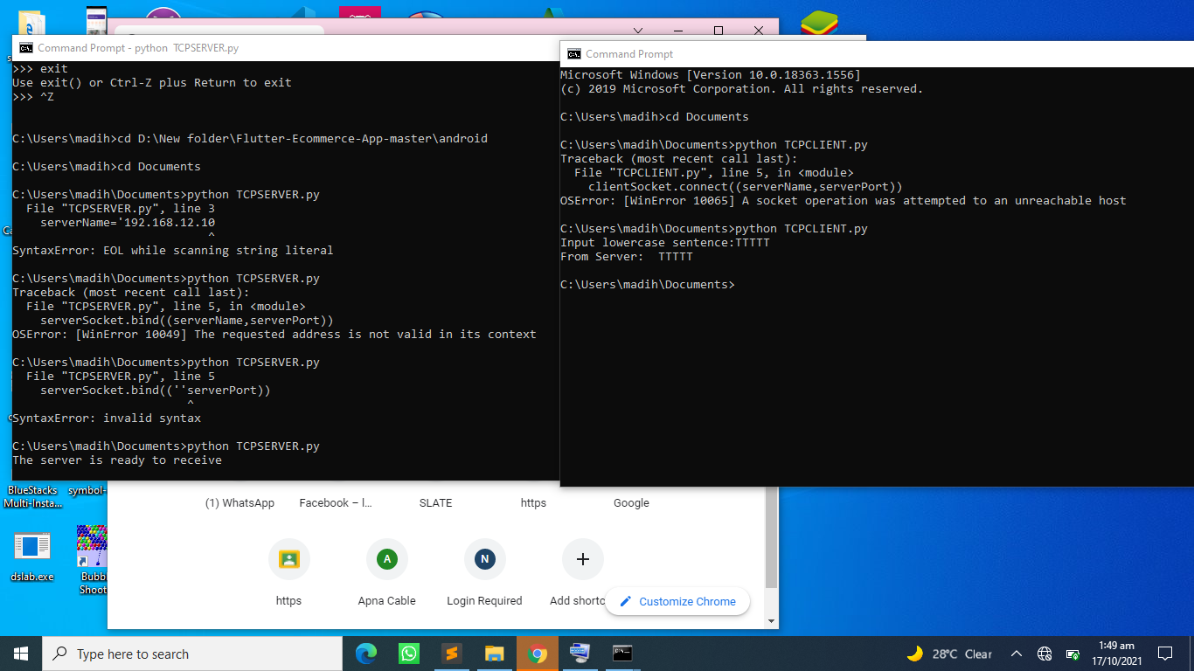

Q4;

**Figure1;**

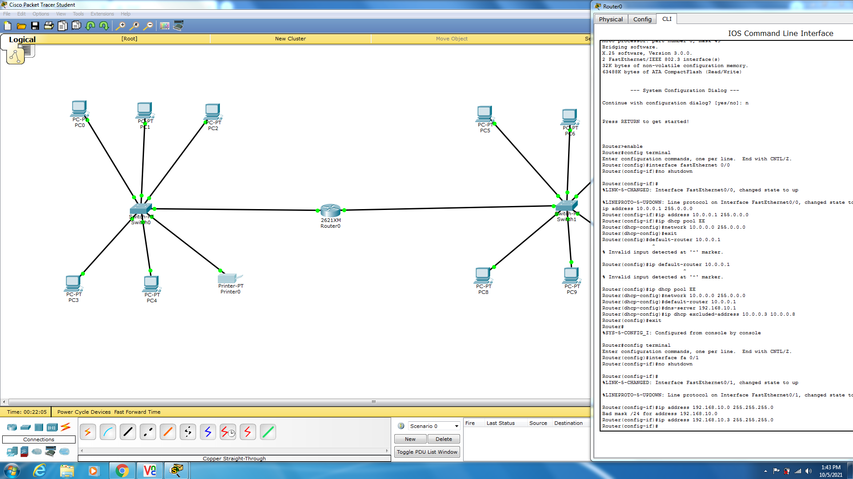

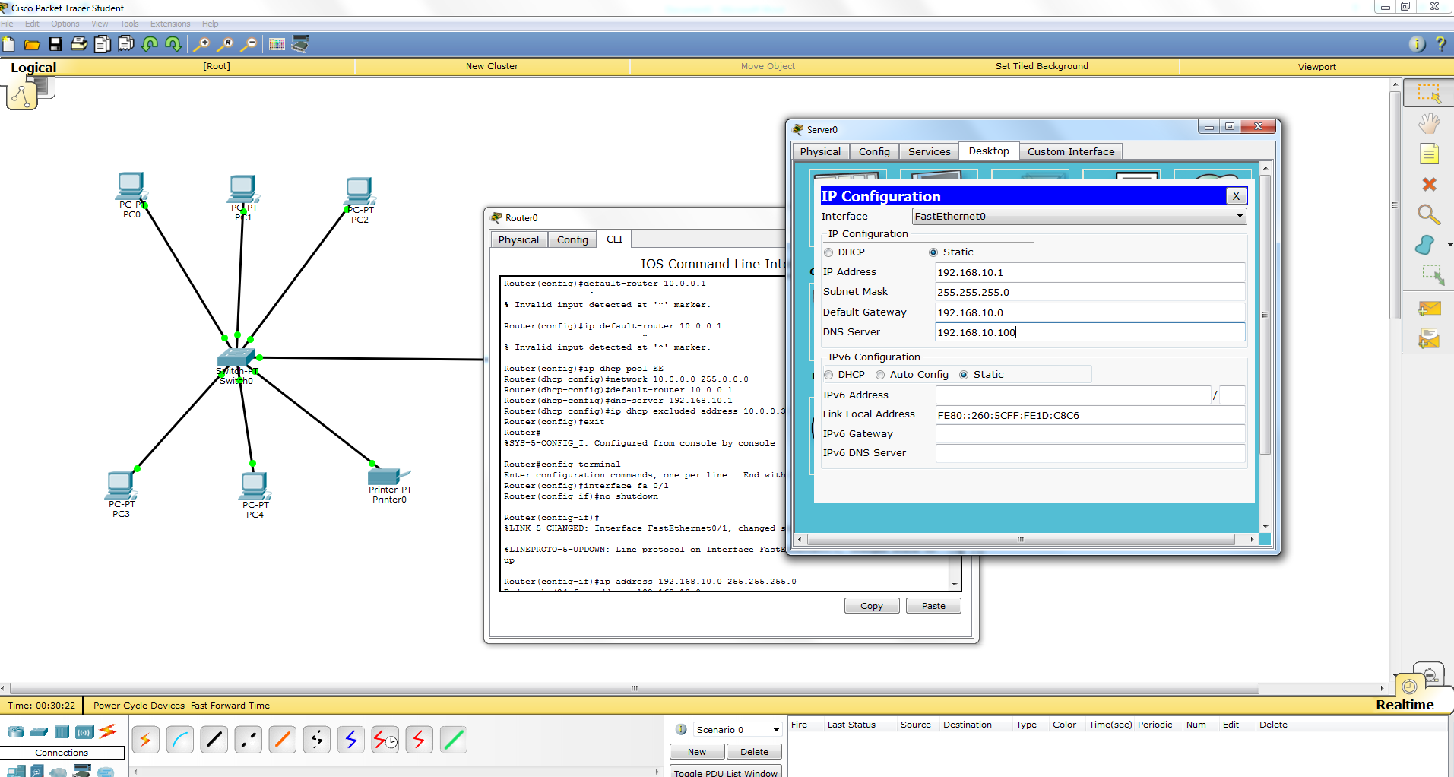

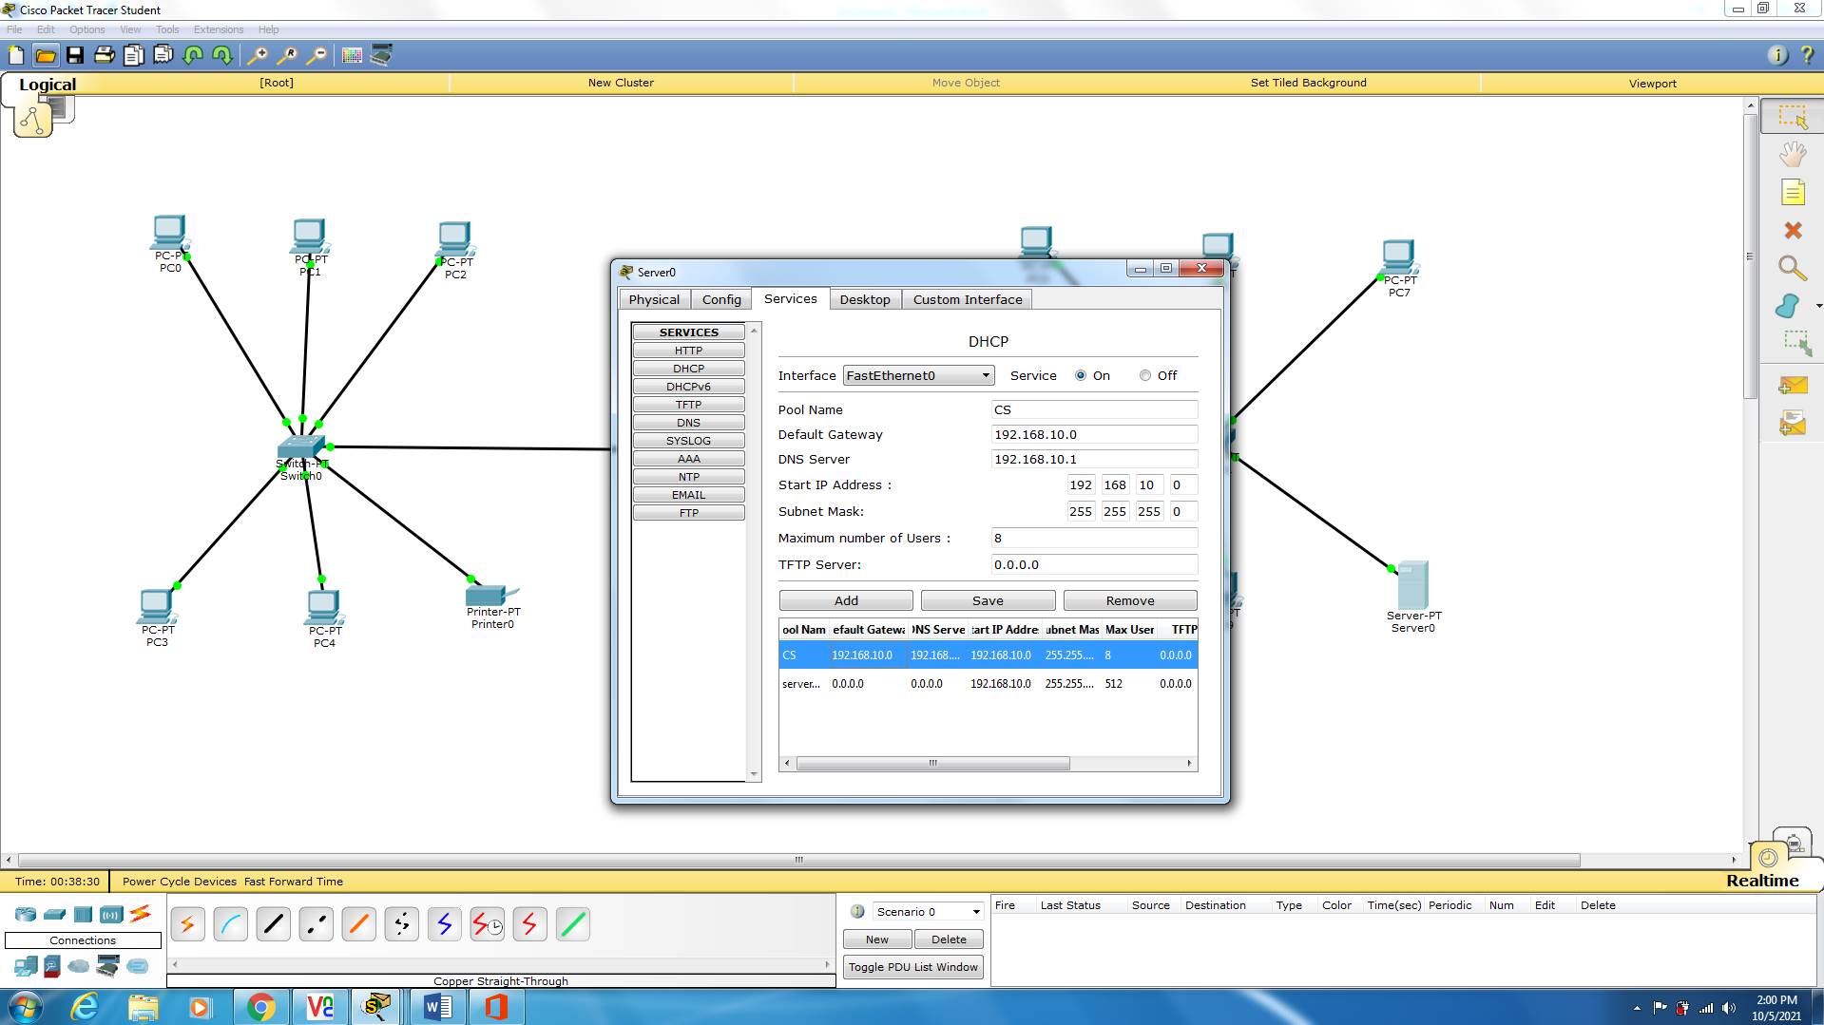

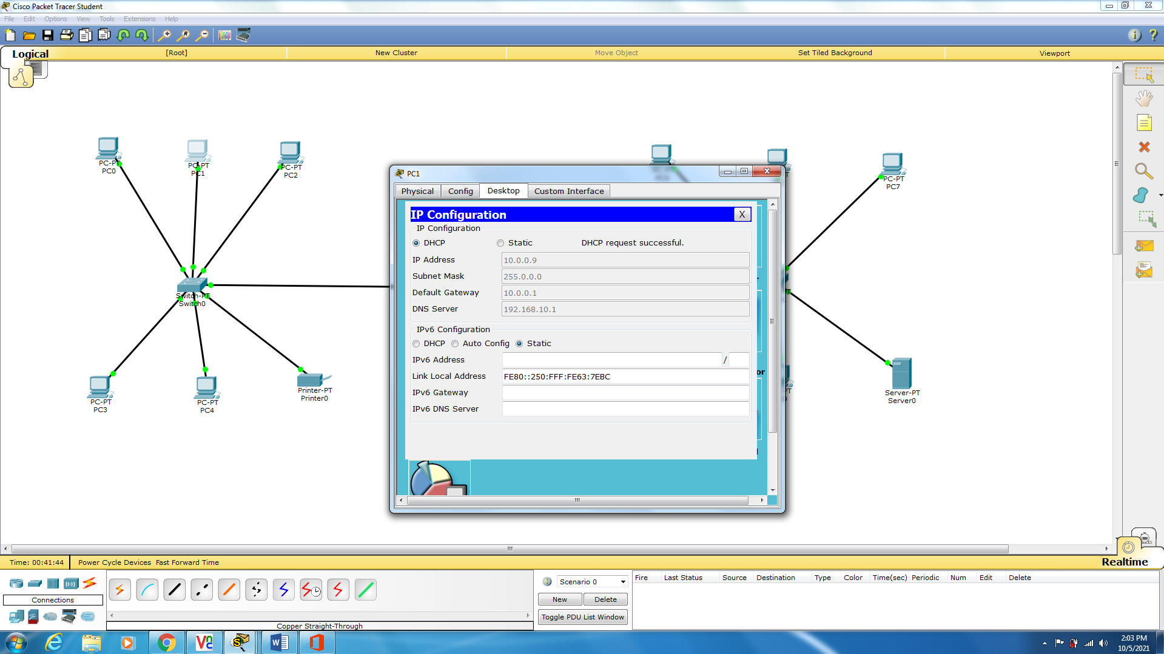

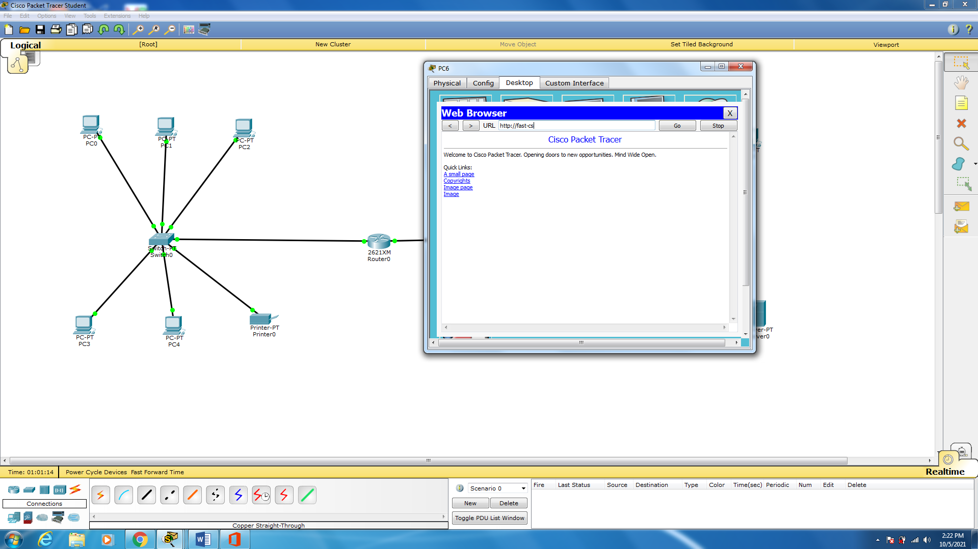

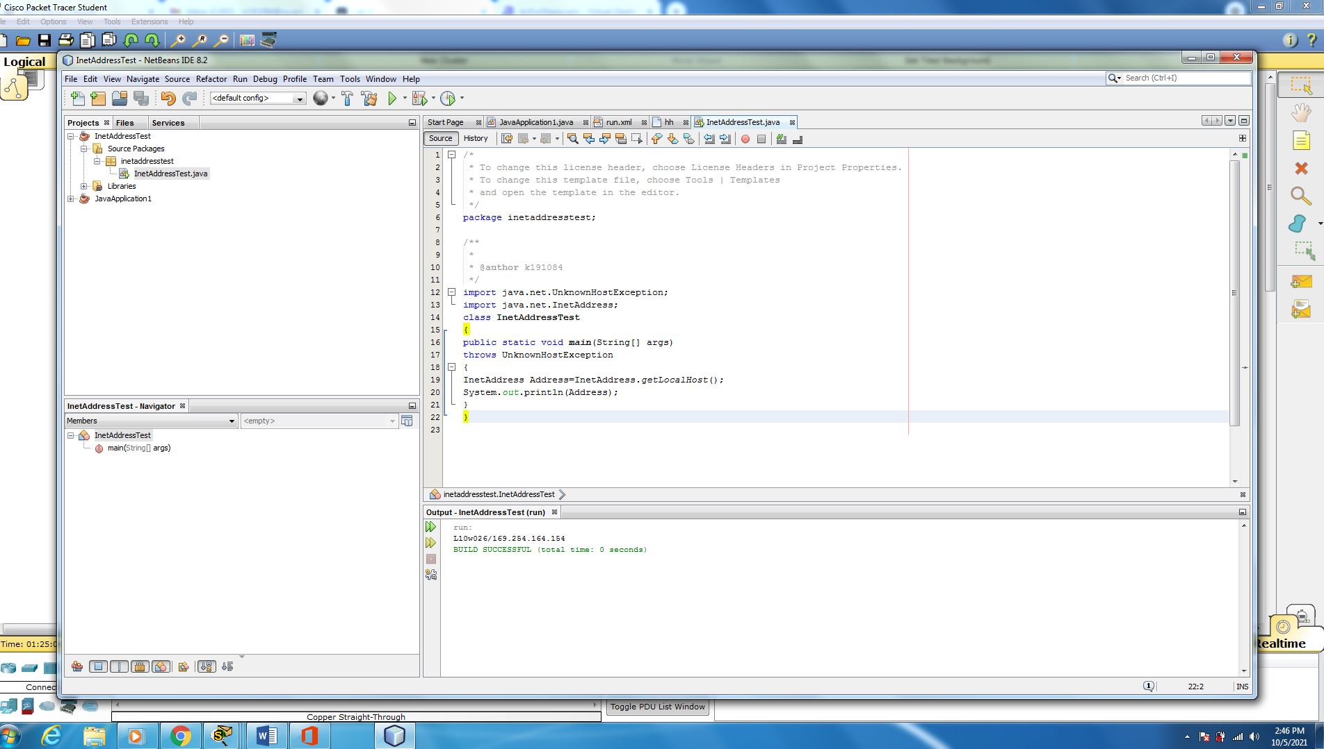

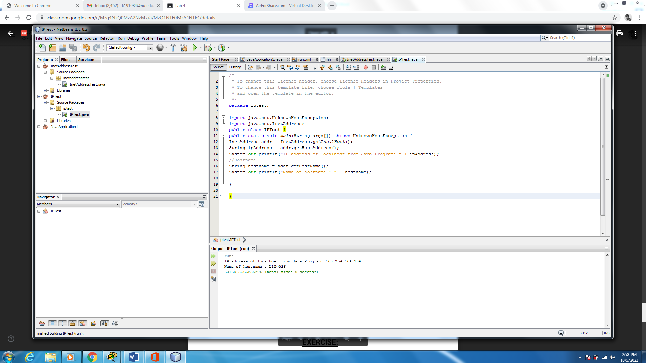

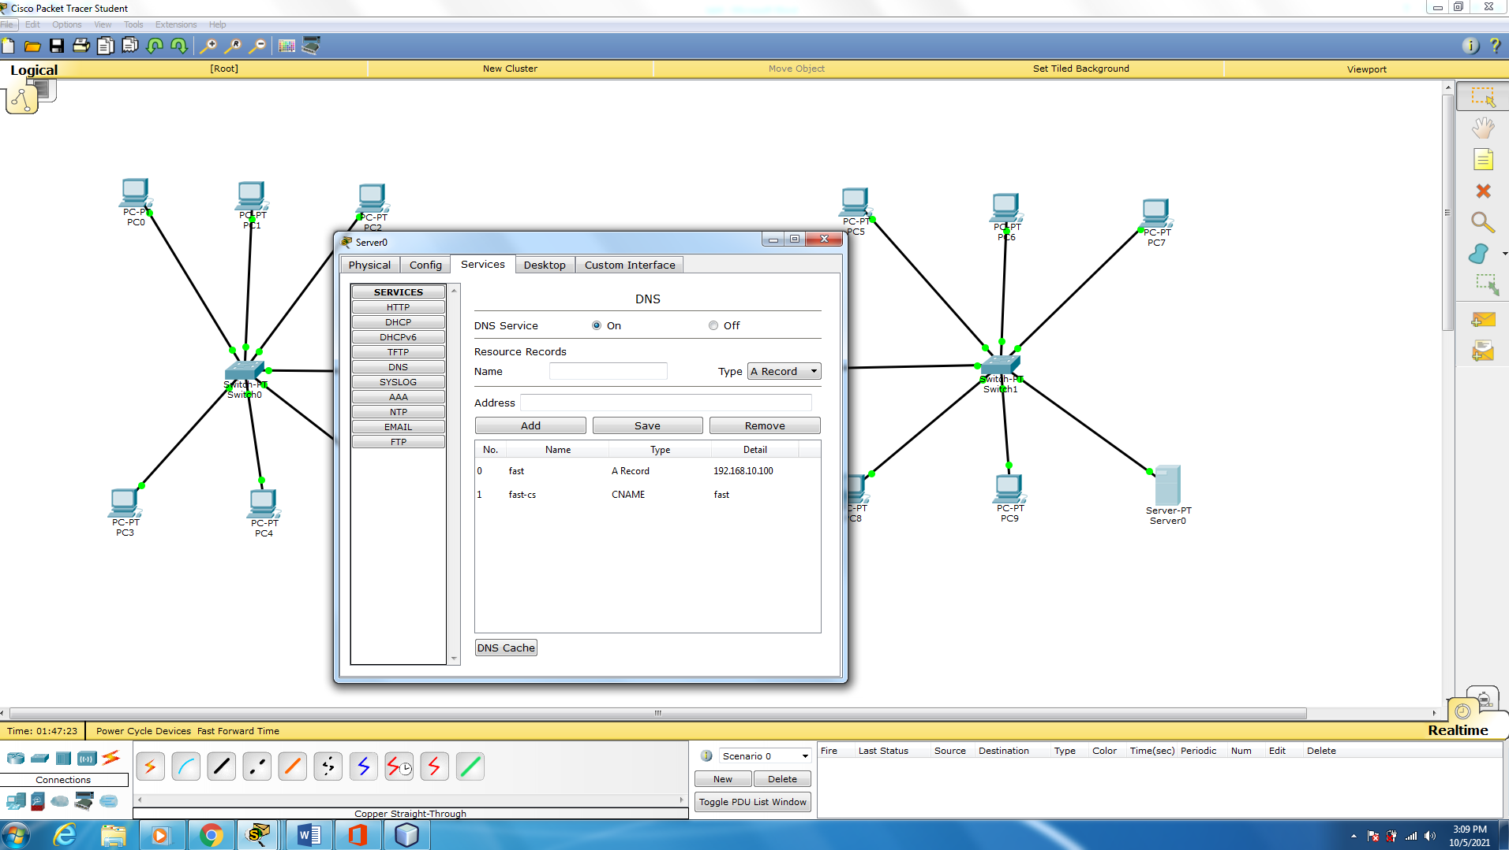

**Figure 2;**

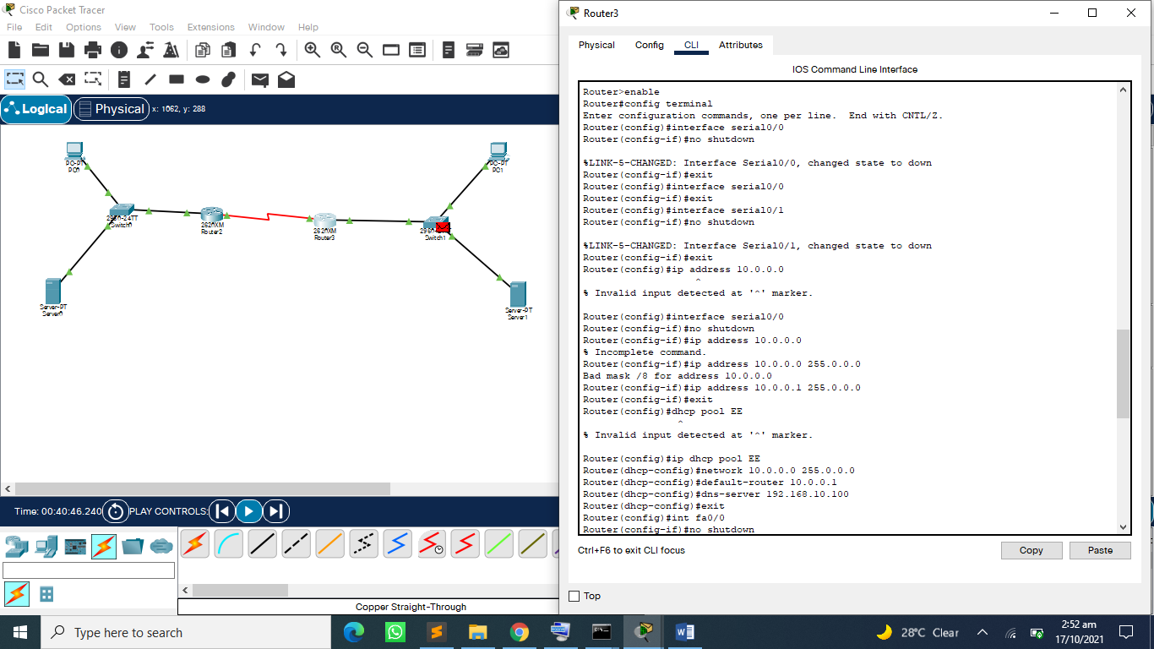

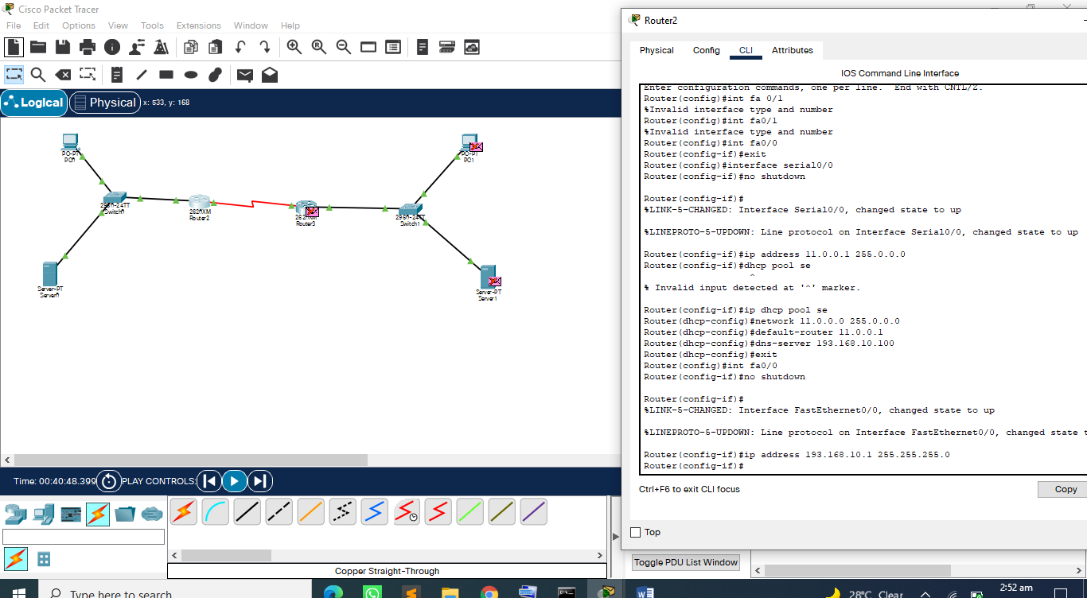

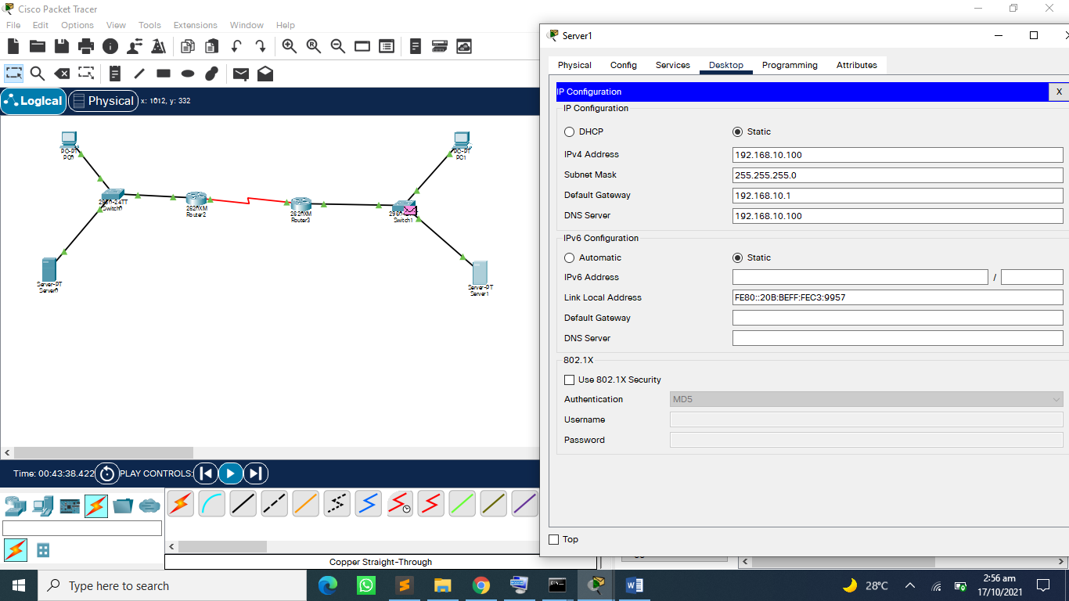

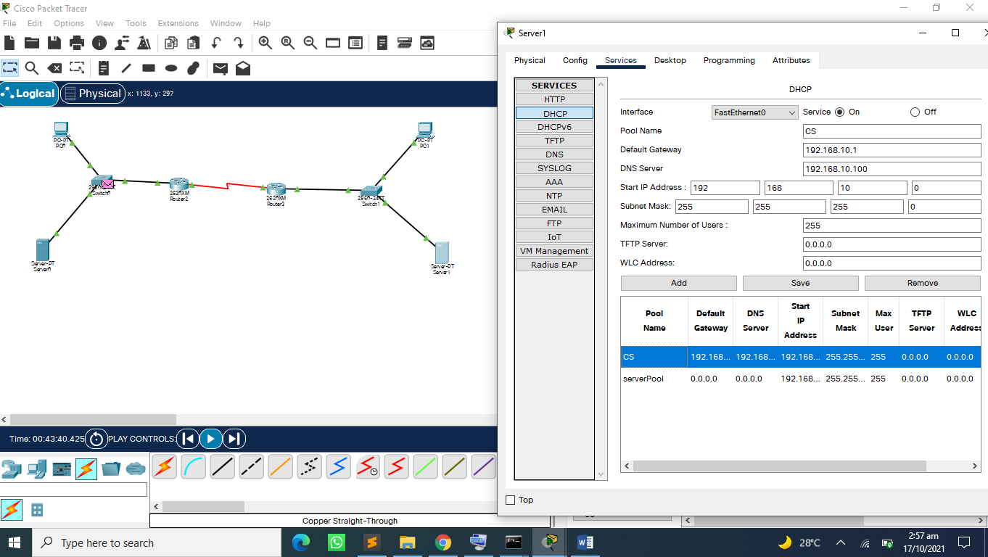

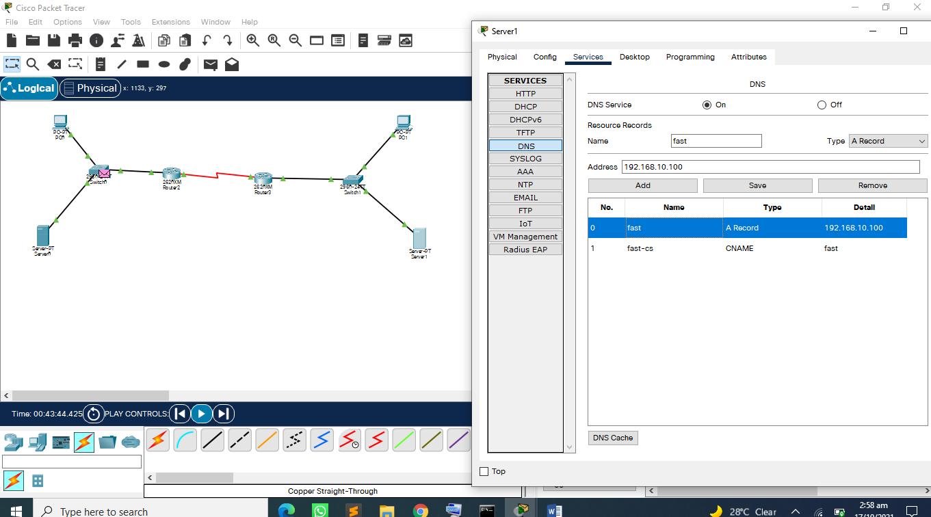

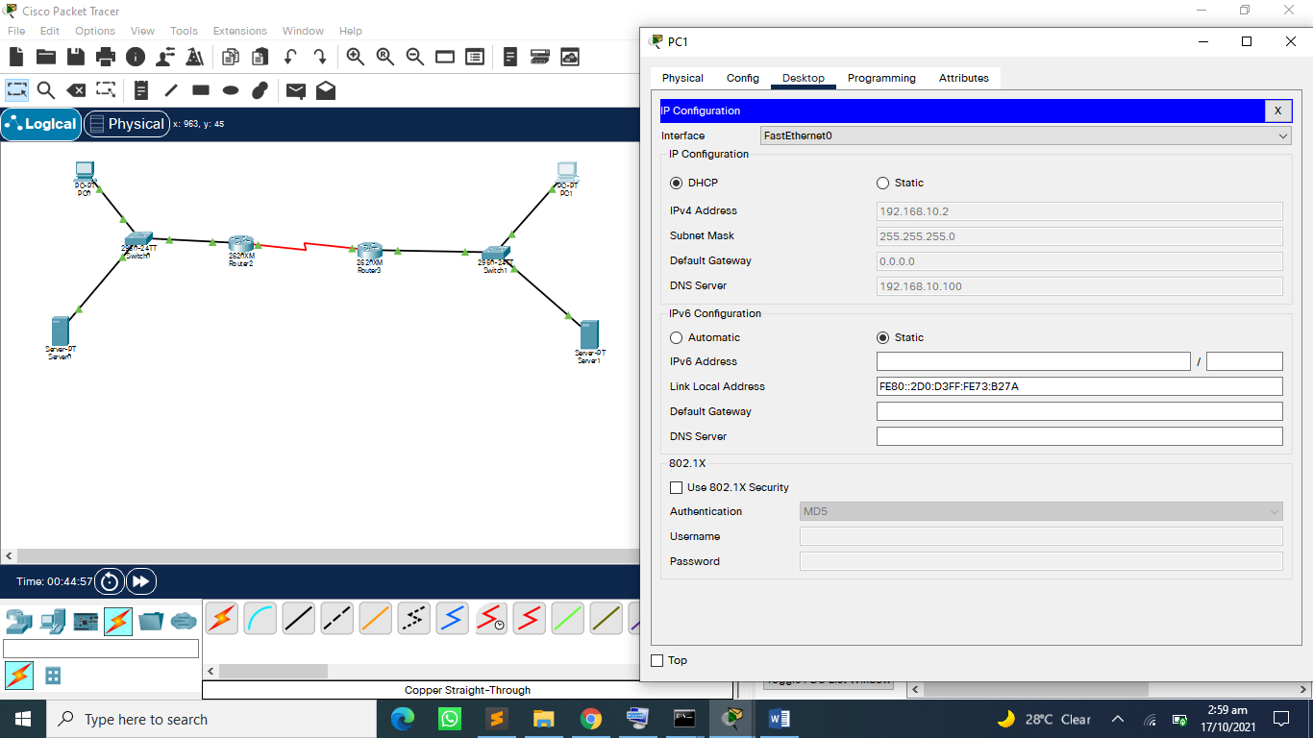

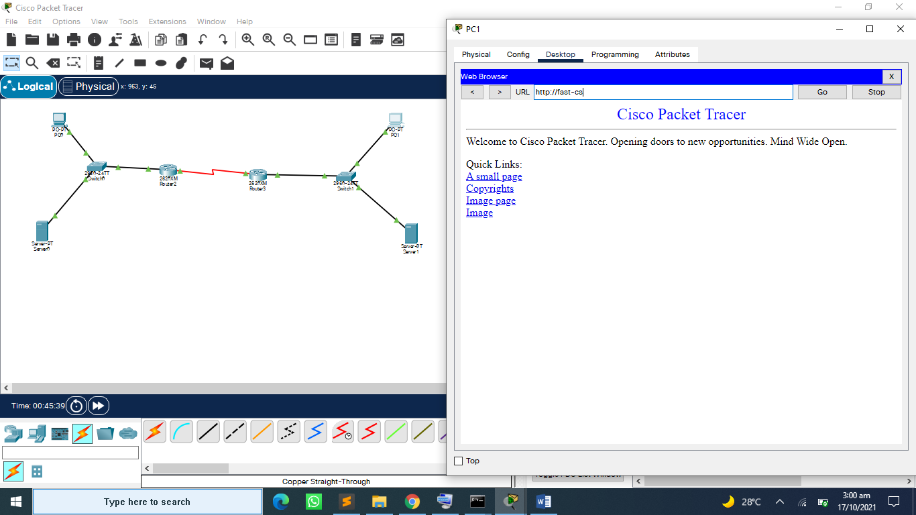

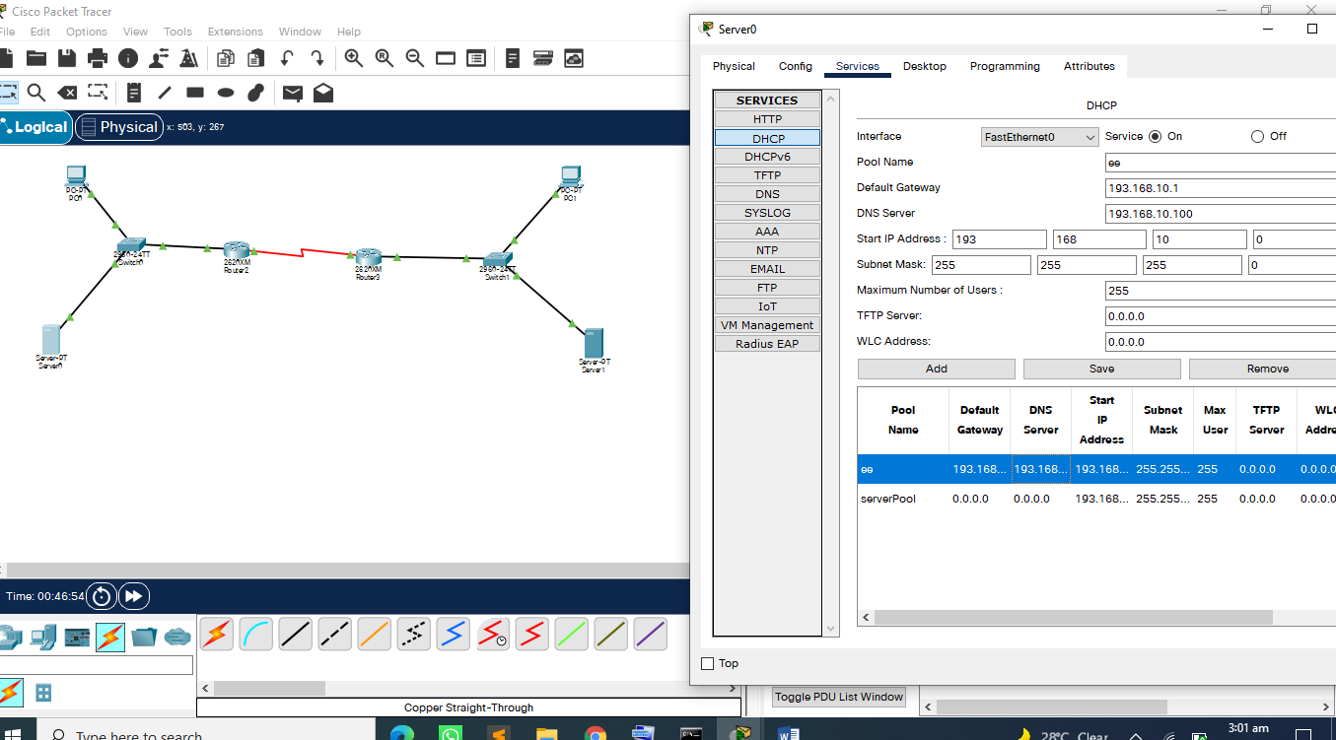

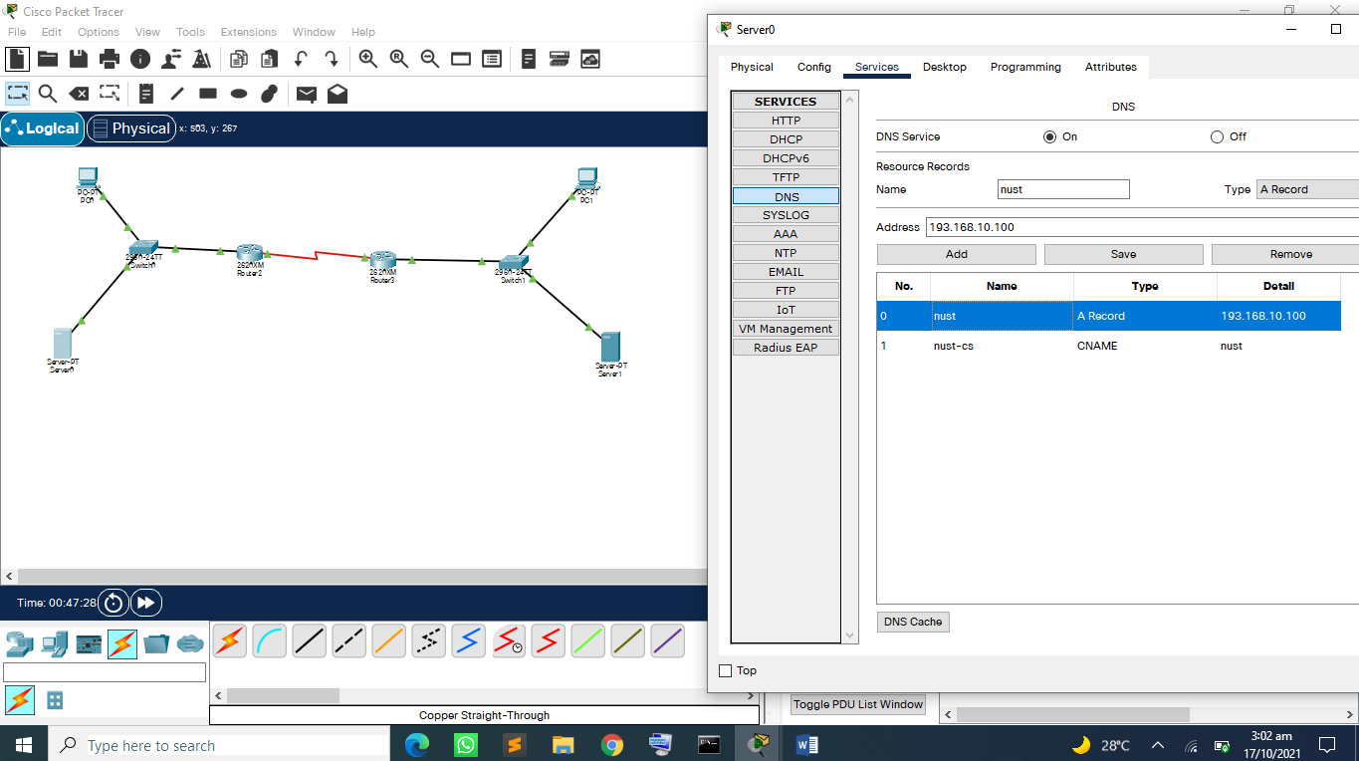

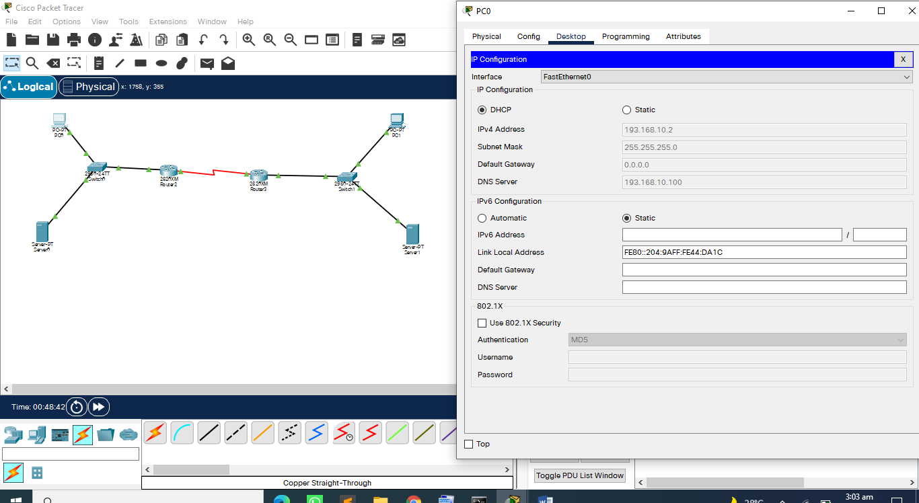

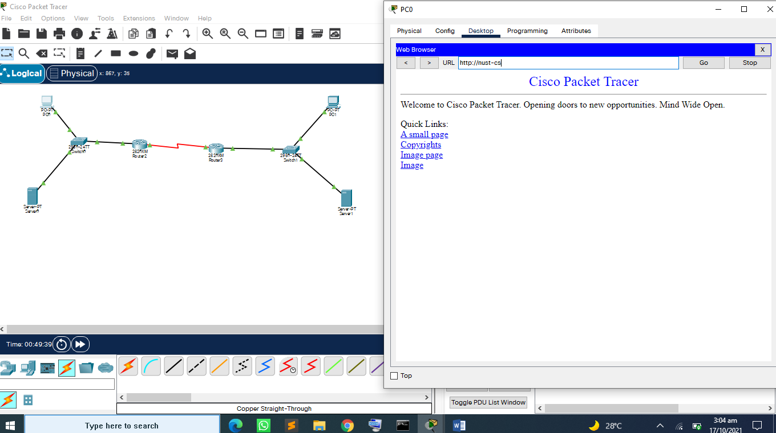

**Pdu-information;**

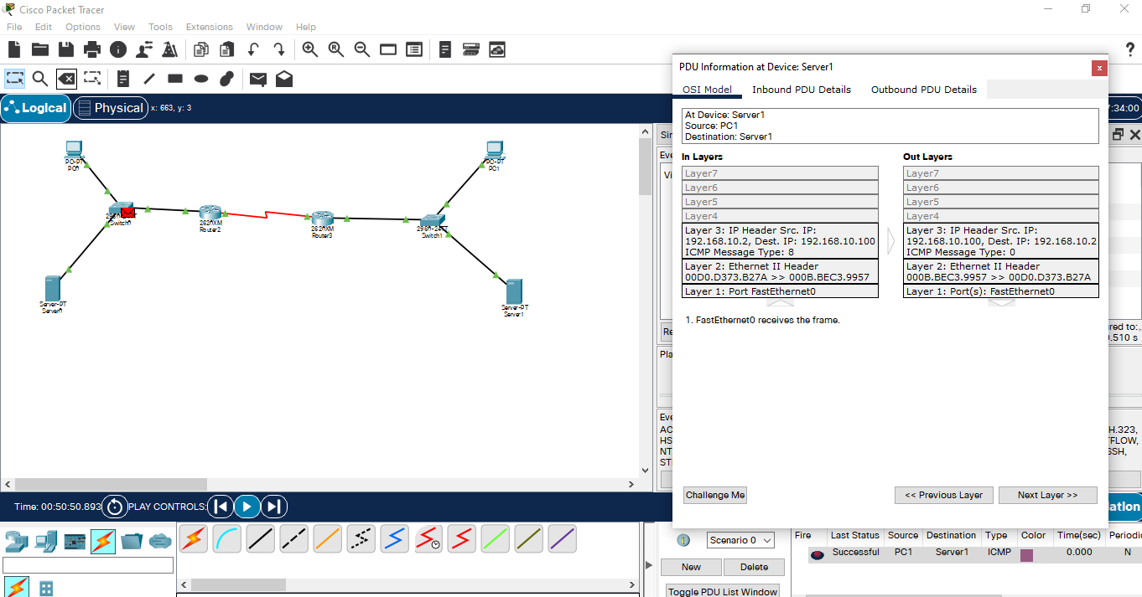

**WIRESHARK ANSWER;**

1. **UDP USER DATAGRAM PROTOCOL**
2. **0.0.0.0 REPRESENTS LOCAL HOST/SERVER POOL.**
3. **255.255.255.255 CLASS E EXPERIMENTAL CLASS.**
4. **0X56F415ED**
5. **5 PIECES ARE;**

* **MESSAGE TYPE; BOOT REQUEST[1] SINGLE CONNECTION**
* **HARDWARE-TYPE; ETERNET [0X01]**
* **HARDWARE LENGTH 6**
* **HOPS**
* **TRANSACTION ID; 0X56F415ED**
* **SRC PORT; 68, DEST PORT; 67**
* **UDP.**